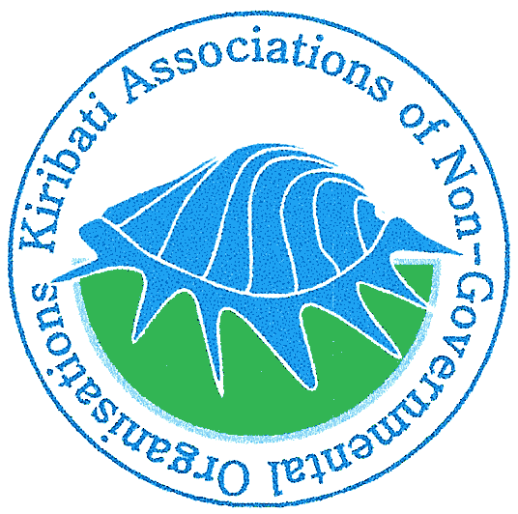
Kiribati Association of Non-Governmental Organizations (KANGO)
P.O Box 162, Bairiki, Tarawa, Republic of KIRIBATI
Incorporated Societies Act 2002 Registration No. 02

17 January 2017

UPDATED REPORT ON KANGO’S PLEDGE TO WHS
- The KSNEP (pronounced kay-snep) Initiative is a component of Goal 3 (Improved Internal & External Partnerships) of the KANGO’s Strategic Development Plan 2016-2019. The KSNEP stands for Kiribati State-NSAs Engagement Process. Overall goal is to scale up engagement with Government of Kiribati (GoK) and Development Partners so as to strengthen the voice and participation of CSOs in public policy processes, whilst sharing info and analysis within CSOs regarding contextual approaches to humanitarian issues.
- KANGO Board circulated the KSNEP concept to all the key NSA stakeholders including AMAK (Aia Maea Ainen Kiribati) which is the national women’s association, KFHA (Kiribati Family Health Association), KNYC (Kiribati National Youth Council), KCSP (Kiribati Civil Society Platform), the KRCS (Kiribati Red Cross Society), the Kiribati Local Government Assocation (KiLGA), and the Kiribati Chamber of Commerce and Industry (KCCI) (Private Sector). The Board also invited their initial reactions and comments to the KSNEP Initiative and these are yet to be received.
- KANGO Board briefed and updated the new President of Kiribati, HE Taneti Maamau about the KSNEP during their courtesy visit with a PIANGO official to the president in November 2016 (see photo below). The president is now aware of the KSNEP in principle, however the Board will be sharing detailed information about the KSNEP to all the Government of Kiribati’s Ministries and Agencies.
- KANGO’s application to the NSA Grant managed by the Pacific Islands Forum Secretariat had received a positive outcome. The application sought funding for full implementation of the KSNEP. The NSA Grant assessors will be visiting Tarawa, Kiribati to undertake the second stage of the assessment.
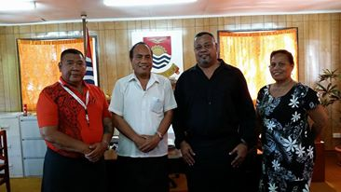

L-R: Mr. Martin Tofinga (KANGO Board), HE President Taneti Maamau, Mr. Laitia Tamata (PIANGO official), Ms. Tereeao Teingiia (KANGO president) at the President’s Office, 24 November 2016

